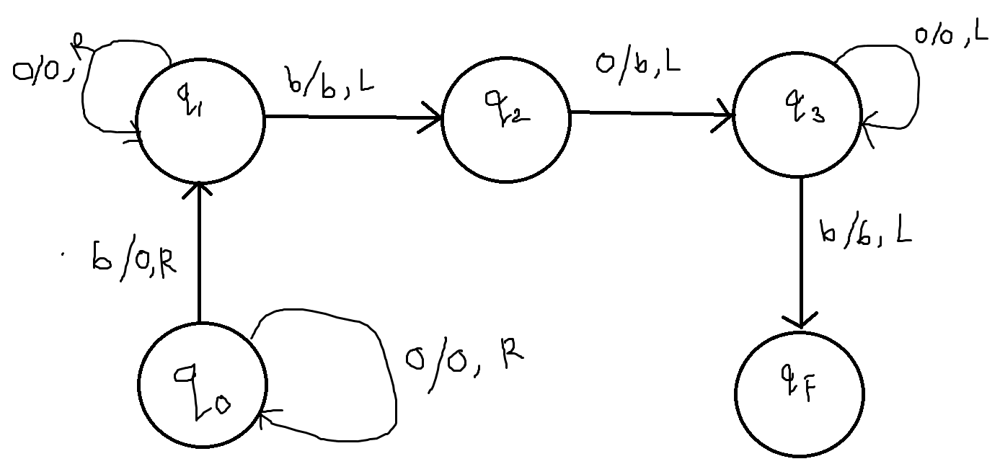

Figure 1: Turing machine for addition